Watershed Lab
Overview

Time: 2 hours
Group Size: Up to 45 participants
Grade Levels: 4th – 5th grade
Location: At Sea, Surf Science Yard, and Maddie James Seaside Learning Center (MJSLC)

PROGRAM DESCRIPTION

In our Watershed Lab program, students explore the science behind watersheds. In the lab, students learn and investigate the health of watersheds through various tests and observations. Using scientific techniques, students perform a fish dissection and discuss the health of the fish. Students will also conduct water chemistry tests and discover potential sources of pollution in our harbor. Lastly, students will engineer a groundwater model to understand the hydrologic cycle and the importance of a healthy watershed.

INTRODUCTION

If the group is even a few minutes late it must be shortened. Stations should start no more than 15 minutes after the program start time, so shorten introduction as needed. If they are more than 15 minutes late in arriving, you will need to do this in 5 minutes and shorten stations as required to finish on time. You may even need to divide groups right away and do your own brief introduction with your group.
While one instructor is giving the intro, another instructor needs to group up the chaperones and give a chaperone talk.
Introduction:
Welcome to the Ocean Institute. Introduce self and instructors.
Ask the students where their school from. This gives us a way to connect with them and where they might be in a watershed. Ask the students what they are here to study. They are here to study watersheds. What is a watershed? (A watershed is an area of land that drains into a body of water. As rainwater and melting snow run downhill, they carry sediment and other materials into rivers, lakes, streams, wetlands, the ocean, and even groundwater!) Do you live in a watershed? (yes) What is your watershed’s outlet? (Answers will vary depending on the area. Dana Point’s local watershed outlet is the San Juan Creek.)
Ask the students what Earth’s four major systems are. (Biosphere = living; Hydrosphere = water; Geosphere = earth; and Atmosphere = air). We’re going to investigate how these systems interact within our watershed by exploring three different lab stations. You will dissect a fish, connecting what you learn to the biosphere; test water quality, connecting what you learn to the hydrosphere; and will engineer a groundwater system, connecting what you learn to the geosphere.
Explain the lab and safety rules.

Chaperone Talk:
Welcome to the Ocean Institute! Thank you for coming and giving your time so your students may have this experience.
Give a brief description of the program, timing, and rotations (ex. During this two hour living systems lab, students will move through four 30 minute stations with their group, each focusing on a different aspect of systems in the ocean and within and organism, and how organisms are adapted to their habitats).
Role of the chaperones:
- Our labs are inquiry-based learning stations meant to challenge and inspire the students, so we ask that you take a step back and allow them to fully engage in all of the stations.
- Please stay with the group you begin with and help the students focus on their work. Please assist with any behavior management issues.
- Your instructor may ask you to supervise the students in the event they need to step away or prepare lab materials, so please be prepared to step in.
- Please help the instructor by taking any students to the bathroom.
- Pictures of students should be candid so as not to distract from activities.
Breaking into Groups:
The instructor that talked to the teacher should give the student count and any information on groups to the instructor doing the introduction. If they have grouped in advance, the teacher will want to use them. If they have not, it is best if the teacher will just let you count off students, so no time is wasted. Do not do a 1- 2- 3 count, just quickly count off the number of students you need without looking like you are picking individual students out. Try to take a mix of both girls and boys. Make sure to count the number of students you have when you get to the first station, make sure you have the right number.

THREE STATIONS

1. Fish Dissection:
Students will examine the external and internal anatomy of a fish. Through observations and dissection, they will analyze the evidence of pollutants in their fish and formulate an argument as to how pollutants might enter the animal’s systems, where they are stored, and how the organs might be affected. They will then connect the health of the fish to the health of the environment in which it lived and will brainstorm how humans can further protect these areas.

2. Water Quality:
Students will test eight factors of a water sample from Dana Point Harbor. They will analyze temperature, pH, salinity, nutrient (nitrate, nitrite, phosphate, ammonia) levels, as well as dissolved oxygen in order to determine if they are within their normal ranges. They will also determine the cause for any shift in range (relating water quality in the harbor to the watershed) and its possible effect on the biosphere.

3. Groundwater Systems and Aquifer Model
The students will explore the interactions between the hydrosphere and the geosphere. They will investigate the movement, infiltration, and storage of water below ground by engineering their own groundwater system to maximize the level of their water table using sediments of different porosities and permeabilities. Students will further explore these terms and their implications using the Aquifer model.

SCHEDULE/LOGISTICS

Perfect Timing Example: (35) Minutes per stations
9:30 – 9:40 Introduction and divide into groups
9:40 – 10:15 Station 1
10:15 – 10:50 Station 2
10:50 – 11:25 Station 3
11:25 – 11:30 Line up and out the door

- Program Set Up:
- If it is the first program of your day, arrive at your When I Work (WIW) start time. Read challenge sheets for equipment and preparation needed for each station. Make sure to get the fish out first, they take time to thaw.
- Watershed dissection is set up the same way as the Living Systems dissection, using some different laminated activity sheets. Please see diagram below for set up.
- The groundwater systems station is split into three different activities: Engineering and testing an aquifer model, exploring the permeability and porosity of substrates, and exploring a Groundwater Model.
- Engineering an Aquifer: You will set up three activity groups around a table (about 3-5 students per group). Each group will have one cup of gravel, one cup of sand, a half cup of clay, a 500mL graduated cylinder full of water, and a one-quart cup. Once the one-quart cups are used, they can not be used by the next group, so during set up you need to set aside three sets of the above materials. To refill the 500mL graduated cylinders at the end of your station, you can allow the students to help and direct them to the sink. They may also help dump out their sediments in a 5 galloon bucket.
- Permeability vs. Porosity: Set up two metal stands with rings attached. In each ring will be a funnel with a filter on the bottom, one funnel containing sand and one containing gravel. Under each ring will be an empty beaker. You will need to fill two additional beakers with water that will be used to pour water through each funnel.
- Groundwater Model: Do not fill the model at the sink and then carry it to its designated location. Place the model on the countertop behind the the wave tank and fill the back of the model using a large pitcher and regular, fresh water (no blue dye). Once the back of the model is full, make sure the pump and the tube are attached and submerge it in the water. Then plug the pump into the outlet on the wall. Water will begin to filter through the model and fill the front side of the model. Keep the model going throughout the program. On the side, prepare a small beaker with dark blue water. Place a pipette on the counter and a syringe to use during the station to remove excess blue water before moving to your next station.

- Bring Them In:
- Decide who will do the introduction during set up time; it is important to start the program on time.
- Staff should go to the front the Ocean Institute when set up is done (at least 10 minutes before program start time). If the science coordinator is not available for check-in, one instructor can talk to the teacher to get numbers, make sure they have checked in, discuss groups, etc. while the other instructors get the students ready to go in and brings up the rear to close the side gate.
- If there is time, you can have the students use the restroom before bringing them into the lab for an introduction. If the school is more than 15 minutes late, please talk to the teacher to see if they can wait to go to the bathroom until lab begins.
- If it is not raining have the students put any gear, backpacks, etc. in the buckets outside of the At Sea building before they come into the room. Make sure students sit on the floor, not blocking the doors to the tank farm or husbandry office.

- Give Introduction and Break into Groups

- Station rotation (35 minutes each): 1) Fish Dissection 2) Groundwater Systems and Aquifer Model 3) Water Quality on MJSLC dock

- Conclusion/Ending Program:
- Finish on time, line them up at the door. Make sure they know their program is over and ask the teacher what is next for them. Direct them to where they need to go. Make sure they understand they are to leave the campus. No eating lunch in the firepit area. Groups can go out into the Native Plant Garden to eat lunch and will not be allowed back on campus until lunch is over. Instructors take a 30-minute break while students are off campus eating their lunch. If their program is not yet completed, return to the Native Plant Garden to pick up the students 10 minutes ahead of program start time (in order to give a 5 minute warning for lunch cleanup and a 5 minute bathroom run).

ROOM DIAGRAMS

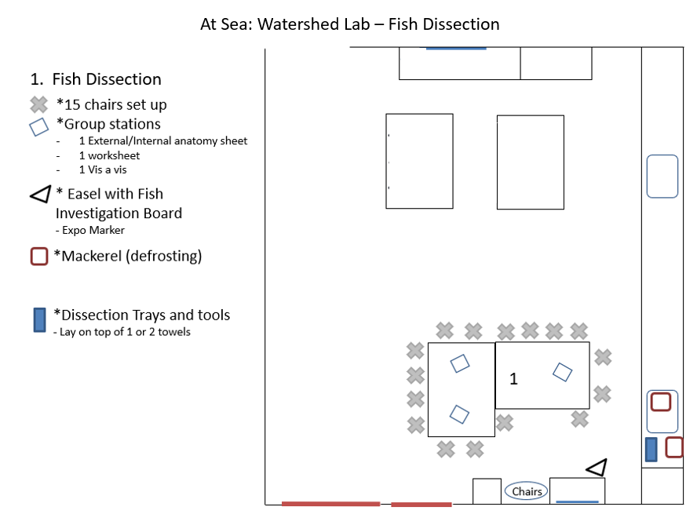

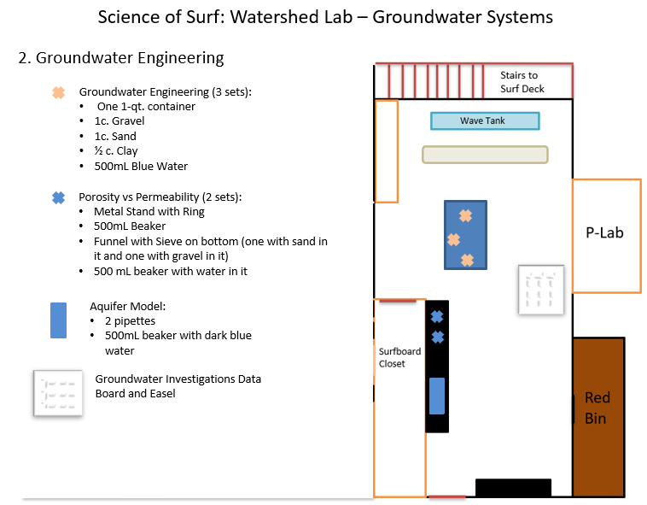

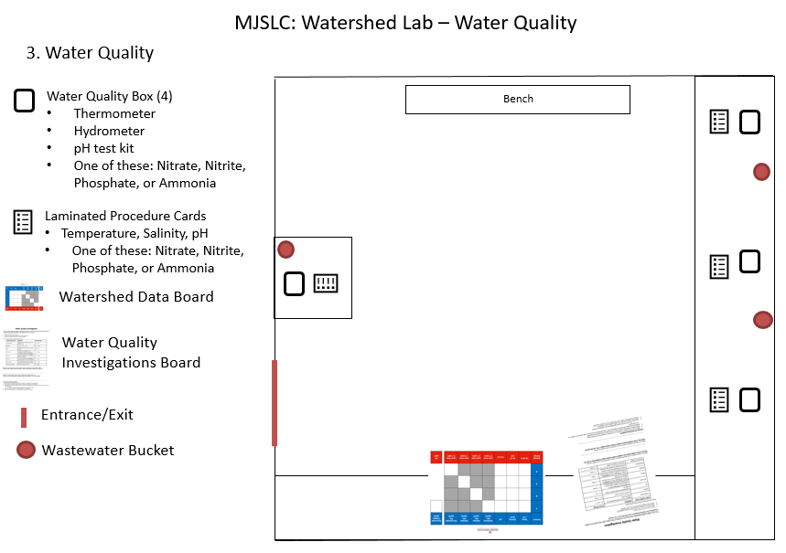

STANDARDS

NGSS EXCERPTS DIRECTLY RELATED TO:
For more in-depth descriptions of these standards, please view at https://www.nextgenscience.org/

3-5-ETS1-2 Generate and compare multiple possible solutions to a problem based on how well each is likely to meet the criteria and constraints of the problem.
4-LS1-1 Construct an argument that plants and animals have internal and external structures that function to support survival, growth, behavior, and reproduction.
- [Clarification Statement: Examples of structures could include thorns, stems, roots, colored petals, heart, stomach, lung, brain, and skin.] [Assessment Boundary: Assessment is limited to macroscopic structures within plant and animal systems.]
5-LS1-1 Support an argument that plants get the materials they need for growth chiefly from air and water.
- [Clarification Statement: Emphasis is on the idea that plant matter comes mostly from air and water, not from the soil.]

5-LS2-1 Develop a model to describe the movement of matter among plants, animals, decomposers, and the environment.
- [Clarification Statement: Emphasis is on the idea that matter that is not food (air, water, decomposed materials in soil) is changed by plants into matter that is food. Examples of systems could include organisms, ecosystems, and the Earth.] [Assessment Boundary: Assessment does not include molecular explanations.]

5-ESS2-1 Develop a model using an example to describe ways the geosphere, biosphere, hydrosphere, and/or atmosphere interact.
- [Clarification Statement: Examples could include the influence of the ocean on ecosystems, landform shape, and climate; the influence of the atmosphere on landforms and ecosystems through weather and climate; and the influence of mountain ranges on winds and clouds in the atmosphere. The geosphere, hydrosphere, atmosphere, and biosphere are each a system.]

5-ESS2-2 Describe and graph the amounts of saltwater and fresh water in various reservoirs to provide evidence about the distribution of water on Earth.
- [Assessment Boundary: Assessment is limited to oceans, lakes, rivers, glaciers, ground water, and polar ice caps, and does not include the atmosphere.]

5-ESS3-1 Obtain and combine information about ways individual communities use science ideas to protect Earth’s resources and environment.

